Game Lab 5 Setting The Bullet Trajectory
We will need to set the initial position of the shell based on the tanks position i.e. the start position will be at the gun position. The shell’s x and y coordinates will be set to that position.
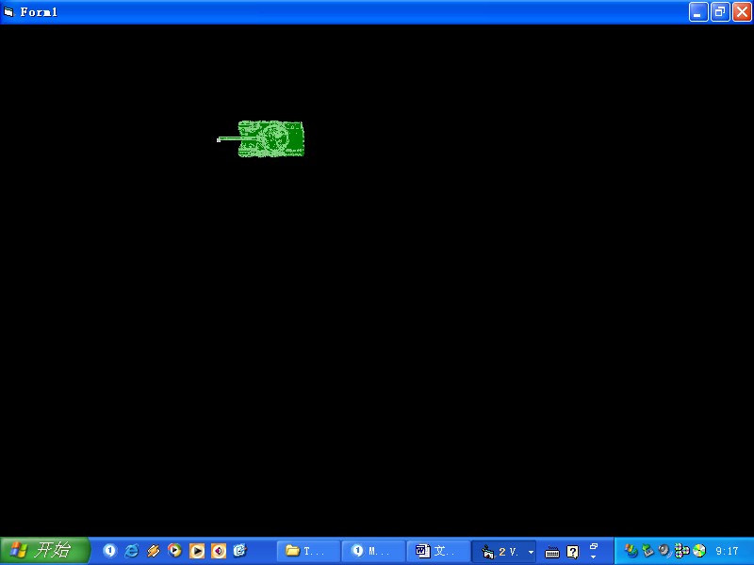
When the tank fires we will need to position the bullet in a position relevant to the tank.
The trajectory i.e. the direction that the shell will move must be set to the direction that the tank is facing – i.e. the trajectory of the shell must be set to the trajectory of the tank.
However, once fired the shell should move independently. If the tank moves in another direction we would want the bullet to carry on in the path set (i.e. the shell’s trajectory) irrespective of the tanks changed position. Setting an independent trajectory for the shell allows for this.
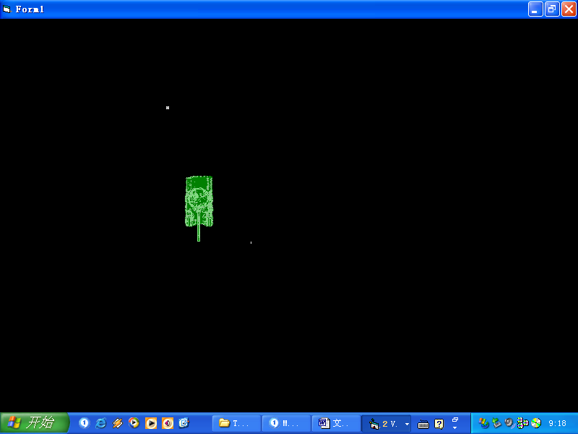
In this case the tank has moved in a new direction downwards but the bullet should still head towards the left.

In order to do this we must set the bullets trajectory path.

Setting the trajectory
The following is in pseudocode – you will need to translate into C#:

You will need to keep values for:

Shellimage X coordinate
shellimagepY coordinate
Tank trajectory
The trajectory of the shell

Set the start position

Set the direction of movement

On KeyPress
……

Case move left:
Set image to left
Set trajectory to left

Case move right:
Set image to right
Set trajectory to right

Case move up:
Set image to up
Set trajectory to up

Case move down:
Set image to down
Set trajectory to down

The code within each case stays the same as in previous labs - apart from 1 line added for each tank direction in order to mark the direction i.e. the trajectory.

Set Initial Values (Not Firing)

At the start of the program run we will nee to set an initial trajectory for the tank i.e. whatever way facing when the form is loaded. We will also need to initialize values for the shell e.g. so that it does not appear on the screen until the player fires

When the form Loads
….
Set initial tank trajectory

Call initialize

End Sub
Code as for previous labs
Set the initial trajectory to the initial direction of tank on load.
Call a function to initialize the values for the player.
The bullet is not firing and its trajectory is set to 0.
The image is set of screen so that it is not seen

We will need to know when a player is firing and when not i.e. in order to move the shell by changing the X and Y coordinates of the shell image. Initially the player will not be firing and the image should not appear on the screen – to signify this

initialiseforp2firing:

Set shell firing to false
Set trajectory of shell to 0
set the shell image x coordinate to -100
set shell image Y co-ordinate to -100

FIRING
Modify the case used for player firing within the key press event
firing ()
Set shell firing to True
Set shell Trajectory
End function
Call the function
The shell is now firing we use a Boolean value to signify this and use it to prevent re-firing i.e. the image being reset to a new position before going offscreen or hitting the target.
We know the trajectory of the tank and so we now call a function to set the trajectory of the shell.
Case Firing Key:
Call the firing Function for player

Setting the Trajectory of the Shell
Sub SET_TRAJECTORY()

If the tank trajectory is 4 then
Set the shell trajectory to 4
Set the shell images X co-ordinate
Set the shell images Y co-ordinate
Refresh the Image

Tank trajectory - The shell trajectory is set to the same trajectory as the tank.

Set the position of the shell image to the midpoint of the tank i.e. where the gun turret is.

You will need to do this for each possible direction:
If the tank trajectory is 1 then
….
If the tank trajectory is 2 then
…
If the tank trajectory is 3 then
… etc.

At the end you should see that each time you fire the shell is set to a position at which the tank fires and remains there and so in the next lab we will build in movement for the shell

